Linux Assignment

Q.1. How to make a directory ?

Ans.MKDIR command Which stands for make a directory to create a new directory.

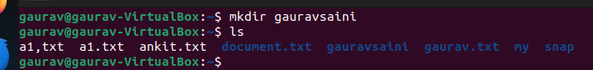

Q.2. Remove a directory ?

Ans. We can use the rmdir command to remove the directory and its contents recursively .

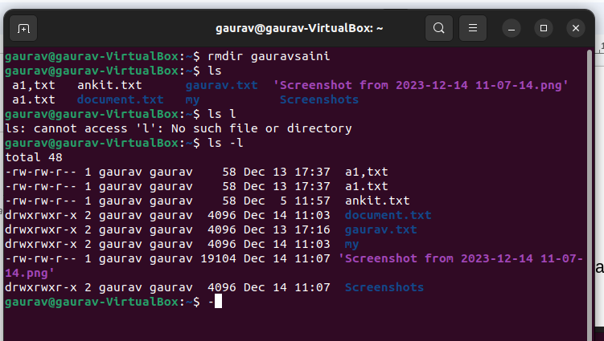

Q.3. Make a copy of a file ?

Ans. Using the cp command make a copy of the file duplicating the content and attribute of a specific file to create an identical or similar file.

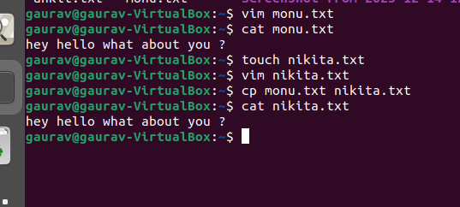

Q.4. Move or rename a file ?

Ans. Mv is a command used to move or rename files and directory in a file system.

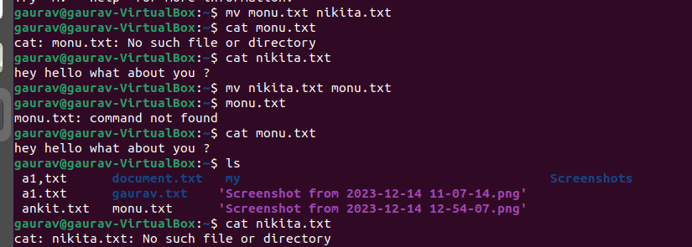

Q.5. Create an empty file ?

Ans. Use the touch command an empty file is a file that contains no data or information. It has a file name and file attributes but doesn’t have any content.

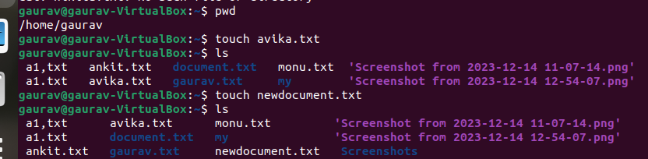

Q.6. Remove multiple files with a single command ?

Ans. IT means deleting multiple file at once using the single “rm” command with the file names seperated by space to remove multiple files simultaneously.

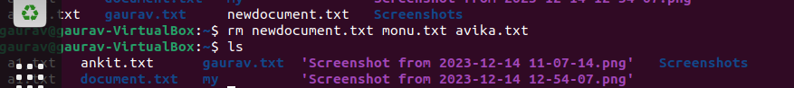

Q.7. Remove content from the folder without removing the folder ?

Ans. Deleting files and subdirectories inside the specified folder while keeping the folder structure intact.It is a way to clean up the content of the folder without deleting the folder itself.

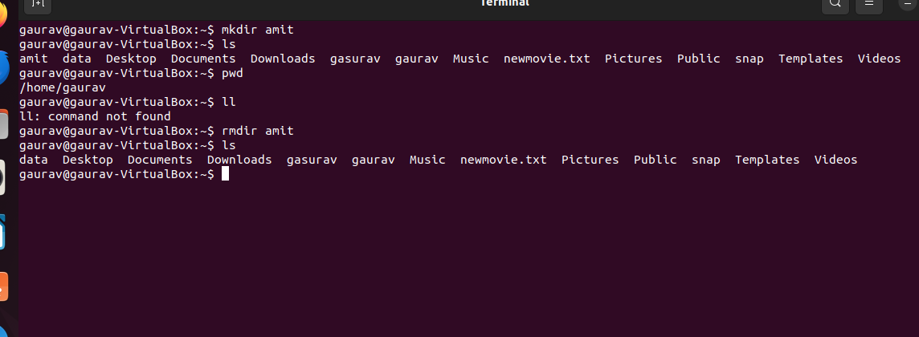

Q.8. Create multiple folders (a-z) with a single command ?

Ans. You can use the following command in a terminal or command prompt.

